L3: Module 8
Aerobic respiration
- Aerobic respiration takes place in Mitochondria. Pyruvate produced during glycolysis is transported from cytoplasm to mitochondria
- Two General steps followed in aerobic respiration….
1. Complete oxidation of pyruvate derived from glucose to 3 molecules of CO₂ by removal of hydrogen atom. This process takes place in mitochondrial matrix.
2. Molecular oxygen serves as electron acceptor for electron removed as a part of hydrogen atom. This process takes place in the inner membrane of the mitochondria. Oxygen is required only in the terminal steps of aerobic respiration, but its presence is very important as it drives the removal of hydrogen by acting as final hydrogen acceptor.
- Oxaloacetic acid is the first member of TCA is regenerated in the last step of the cycle. Thus this cycle can oxidize an unlimited number of acetyl groups.
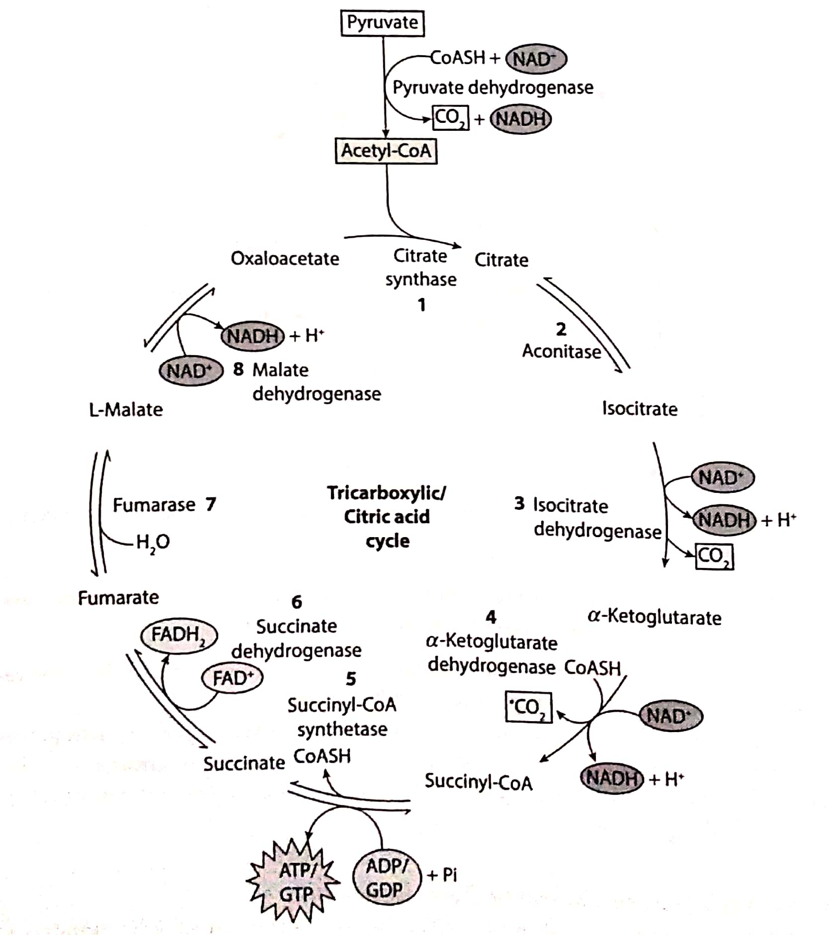
Balance sheet of Respiratory process
Since, 1NADH=3ATP
In glycolysis: 2ATP + 2NADH (will form 3ATP molecule in ETS) = 8ATP molecules
In link reaction- 2NADPH (will form 3ATP molecule in ETS)= 6ATP molecules
In Kreb’s cycle- 2ATP + 6NADH (6×3=18ATP) + 2FADH2 (2×2= 4 ATP)= 24 ATP
Total ATP= 38 ATP
