L3: Module 4: Biomolecule
(III) Carbohydrates
A carbohydrate is a biomolecule consisting of carbon (C), hydrogen (H) and oxygen (O) atoms, usually with a hydrogen–oxygen atom ratio of 2:1 (as in water).
This composition gives carbohydrates their name: they are made up of carbon (carbo-) plus water (-hydrate).
Carbohydrate chains come in different lengths, and biologically important carbohydrates belong to three categories: monosaccharides, disaccharides, and polysaccharides.
Carbohydrates are the sugars, starches and fibers found in fruits, grains, vegetables and milk products.
Monosaccharide or simple sugar: contain 3-7 carbon atoms. It can easily cross Plasma membrane
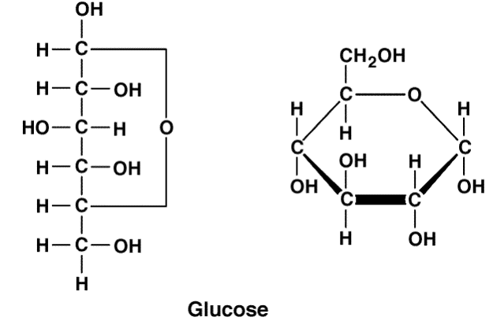
Fig- Linear and Ring structure of Glucose
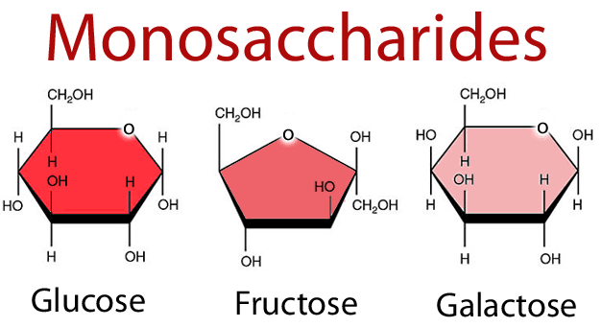
Disaccharide- Simple sugar formed from the combination of two monosacchrides by dehydration synthesis.
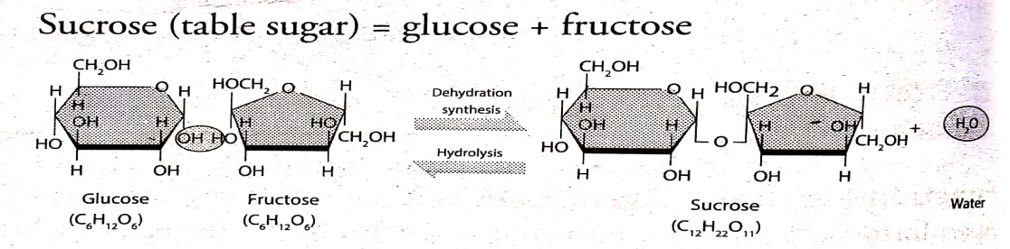
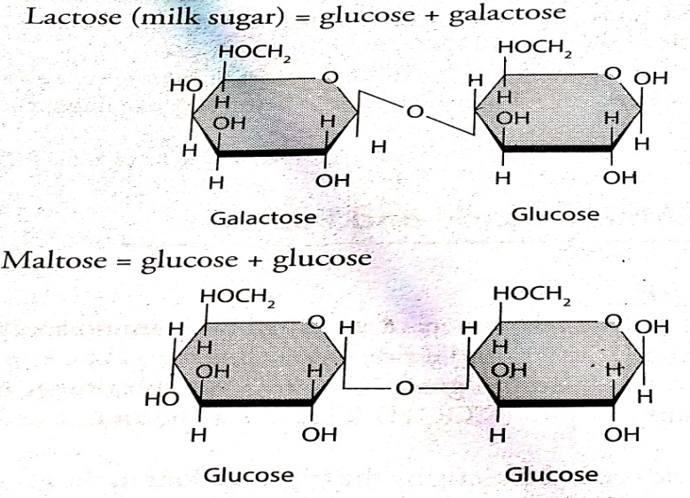
Polysaccharides: is made up of 10-100 of monosaccharides joined by dehydration synthesis.
Examples:
1. Glycogen- Stored form of carbohydrates in animals
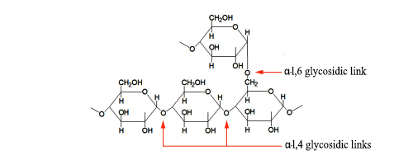
2. Starch- Stored form of carbohydrates in plants and main carbohydrate in foods
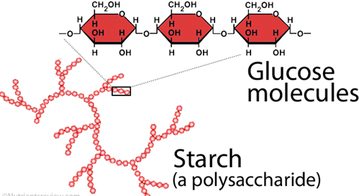
3. Cellulose- part of cell walls in plants that cannot be digested by human but aids movement of food through intestine.
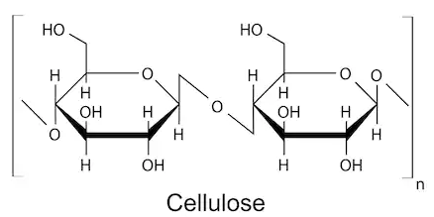

Function of Carbohydrates
1. Carbohydrates serves as major source of energy in animal body.
2. They are essential component of production, temperature control and proper functioning of different part of animal body.
3. They are essential component of milk as lactose.
4. They are stored as glycogen, excess of carbohydrate in diet is converted into fats and stored in fat depot. These are reserve energy material of the body in liver and muscle of animal and starch in plant.
5. Carbohydrate are helpful in absorption of calcium and phosphorous in young animals
6. They help in the secretion of digestive juice in gastrointestinal tract.

