Protein as Receptor
Receptor
In biochemistry and pharmacology, receptors are chemical structures, composed of protein, that receive and transduce signals that may be integrated into biological systems.
These signals are typically chemical messengers, which bind to a receptor, they cause some form of cellular/tissue response.
There are three main ways the action of the receptor can be classified: relay of signal, amplification, or integration. Relaying sends the signal onward, amplification increases the effect of a single ligand, and integration allows the signal to be incorporated into another biochemical pathway.
Types of receptors…..
1. Intracellular receptors are receptor proteins found on the inside of the cell, typically in the cytoplasm or nucleus. In most cases, the ligands of intracellular receptors are small, hydrophobic (water-hating) molecules, since they must be able to cross the plasma membrane in order to reach their receptors.
For example, the primary receptors for hydrophobic steroid hormones, such as the sex hormones estradiol (an estrogen) and testosterone, are intracellular.
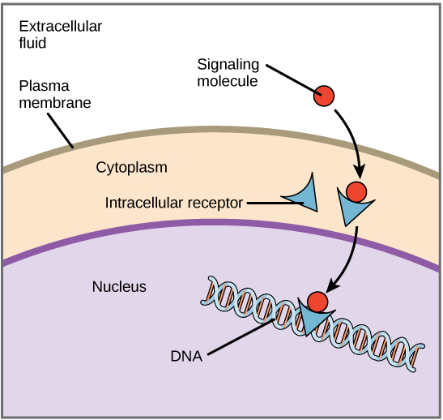
2. Cell-surface receptors are membrane-anchored proteins that bind to ligands on the outside surface of the cell. In this type of signaling, the ligand does not need to cross the plasma membrane.
So, many different kinds of molecules (including large, hydrophilic or "water-loving" ones) may act as ligands.
A typical cell-surface receptor has three different domains, or protein regions: a extracellular ("outside of cell") ligand-binding domain, a hydrophobic domain extending through the membrane, and an intracellular ("inside of cell") domain, which often transmits a signal.
Three common types: ligand-gated ion channels, G protein-coupled receptors, and receptor tyrosine kinases.
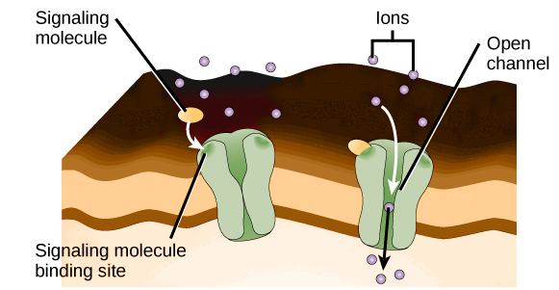 ligand-gated ion channels
