L2 Module 8: Metabolism
Respiration
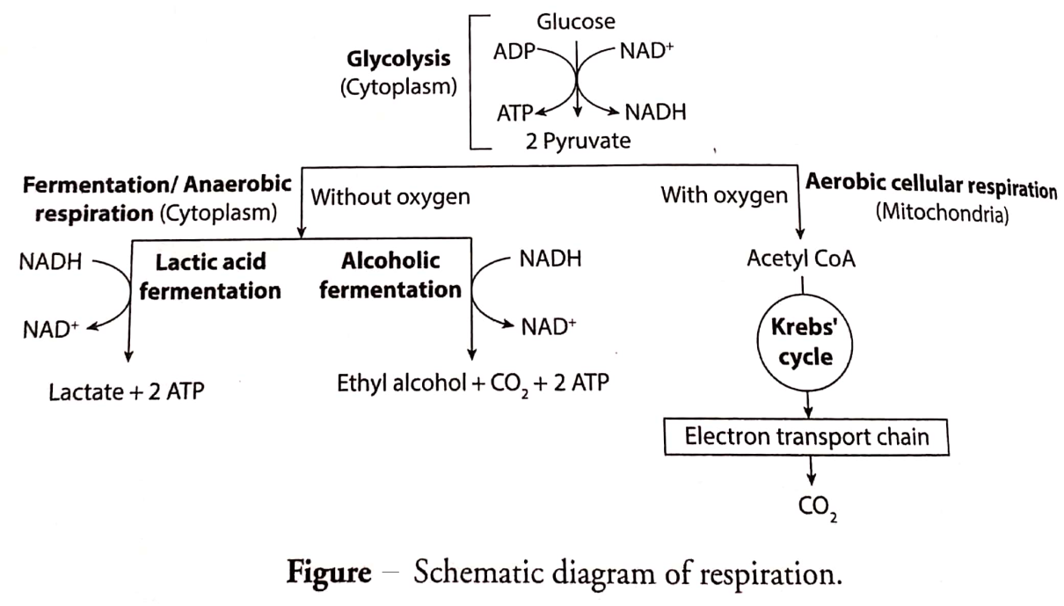
Glycolysis
- Glycolysis is the metabolic pathway that converts one molecule of glucose into two molecules of pyruvate.
- The free energy released in this process is used to form the high-energy molecules-2 molecules of ATP (adenosine triphosphate) and one molecule of NADH (reduced nicotinamide adenine dinucleotide).
- Glycolysis is an oxygen-independent metabolic pathway.
- In most organisms, glycolysis occurs in the cytosol.
- In Plant, source of glucose is sucrose and other stored carbohydrates. Sucrose is produce as a result of photosynthesis.
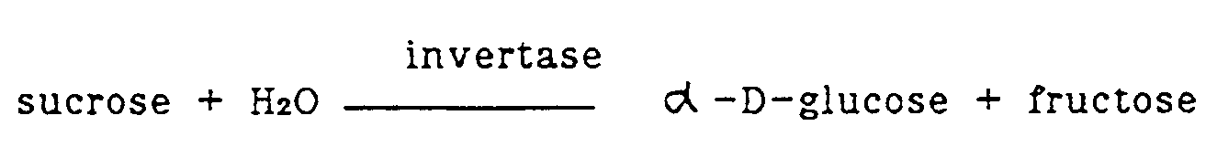
- In animals, glucose is present in the blood as a result of breakdown of dietary starch or glycogen present in liver. It can also synthesized from non-carbohydrate precursors by a process known as glucogenesis.
- The glycolysis pathway can be separated into two phases:
A. The Preparatory (or Investment) Phase – wherein 2 molecules of ATP is consumed.
B. The Pay Off Phase – wherein 2 molecules of ATP are produced.
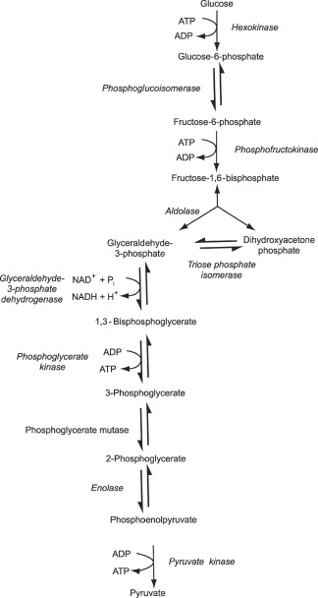
Schematic diagram for two stages of glycolysis
Fermentation/Anaerobic Respiration- in absence of oxygen
- Fermentation is an anaerobic biological process by which cell extract energy from glucose.
- Under anaerobic conditions, pyruvic acid can be routed by the organism into one of three pathways: lactic acid fermentation, alcohol fermentation or cellular (anaerobic) respiration.
- Humans cannot ferment alcohol in their own bodies, we lack the genetic information to do so.

- Alcohol fermentation is the formation of alcohol from sugar. In Yeast, under anaerobic conditions, glucose is converted to pyruvic acid via the glycolysis pathways, then converting pyruvic acid into ethanol.
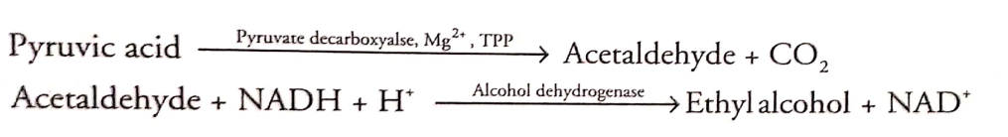
- Lactic acid fermentation- In some bacteria or in muscle of animals, under anaerobic condition, pyruvic acid is reduced to lactic acid.

