**L2 Module 5: Enzyme**

**Mechanism of enzyme action**

http://cdn.biologydiscussion.com/wp-content/uploads/2016/11/clip_image002_thumb-244.jpg

There are two types of mechanisms involved to explain substrate-enzyme complex formation; **lock and key theory** (template model), and **induced-fit theory**.

**Lock and Key Hypothesis**

Given by Emil Fischer in 1894

In this, substrate gets fits into the active site of enzyme as a key fit in lock. Enzyme is specific to substrate due to complementary shapes of enzyme and substrate.

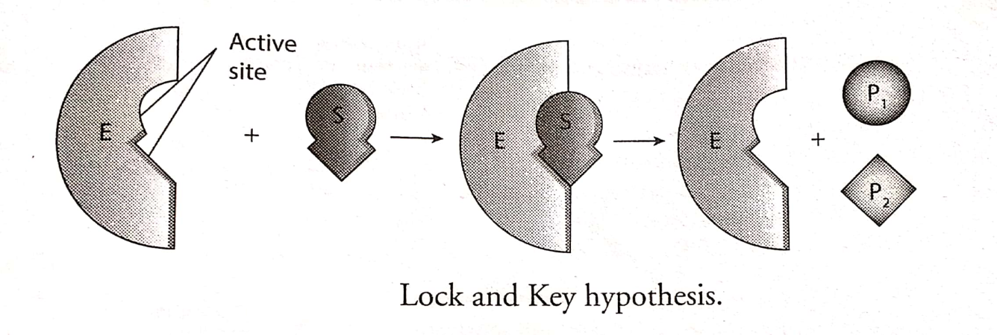

**Induced-Fit model-** It is given by Daniel Koshland in 1958. In this model, the active site changes its shape to fit around the substrate once the substrate enters the active site. The substrate induces a changes in enzyme shape to fit the shape of the substrate.

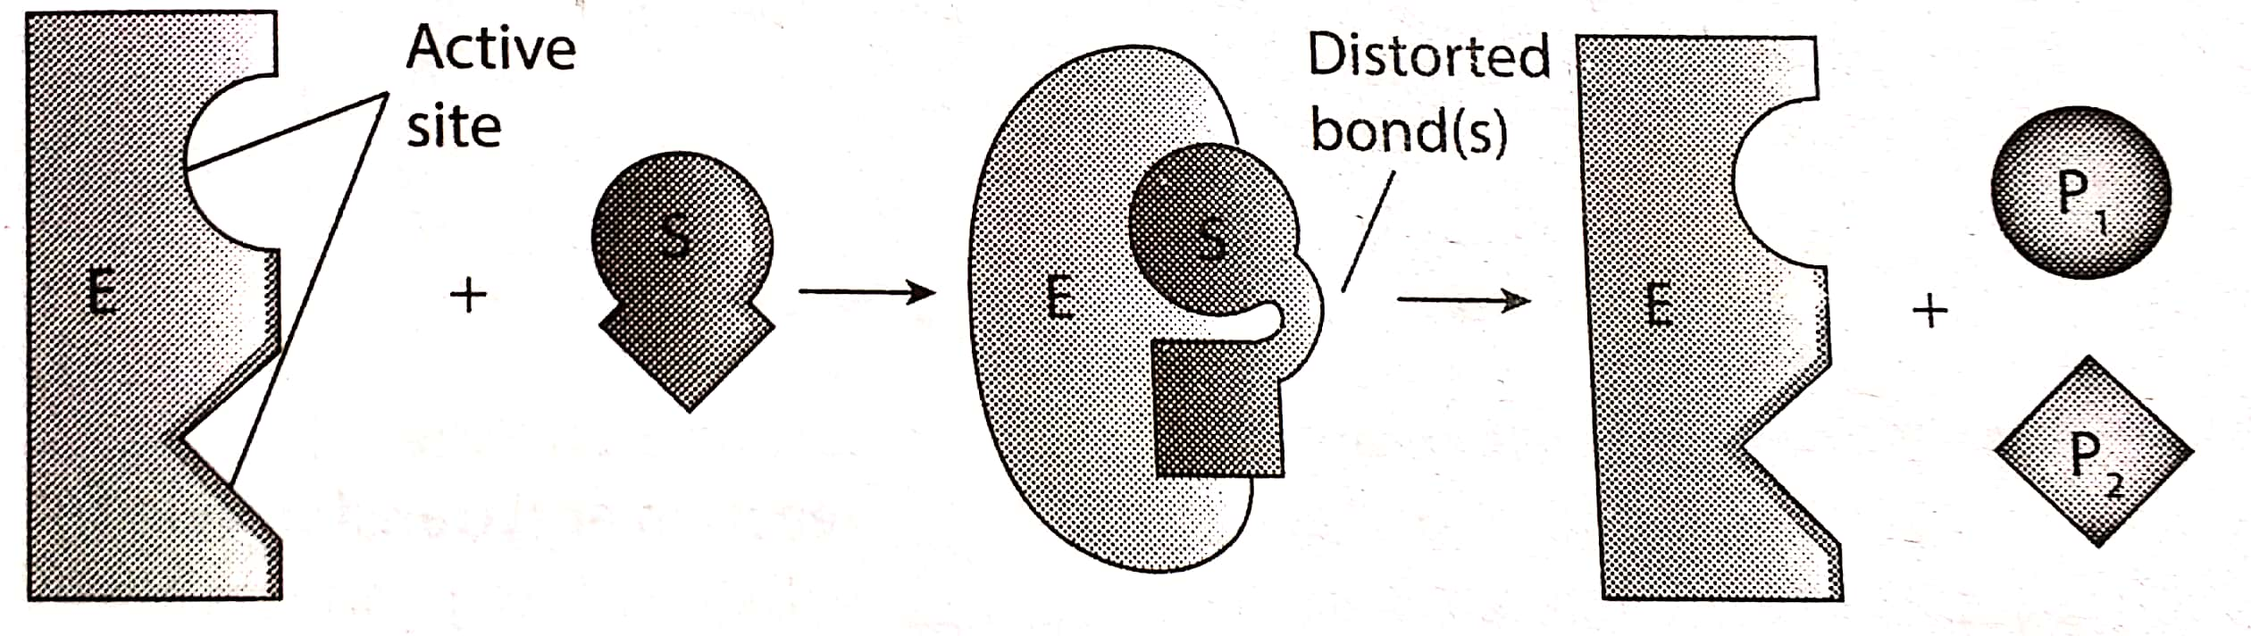

Induced – Fit model

Examples: (A) Catalytic action of **sucrose enzyme**

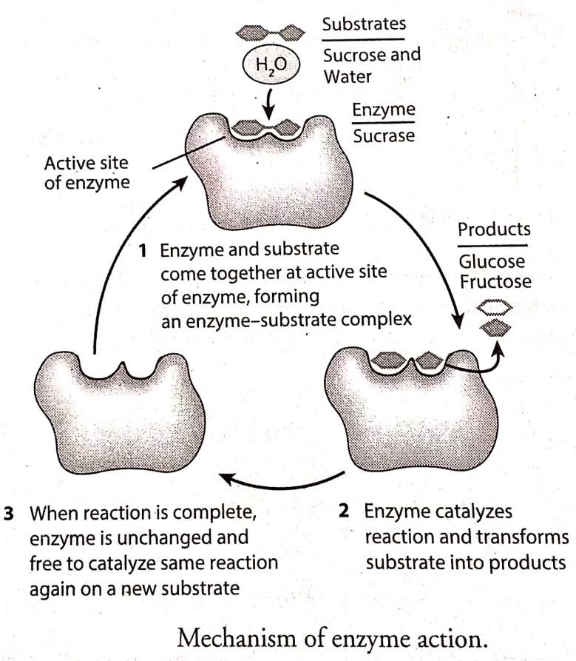

(B) Catalytic action of Fructose-1.6- biphosphatase

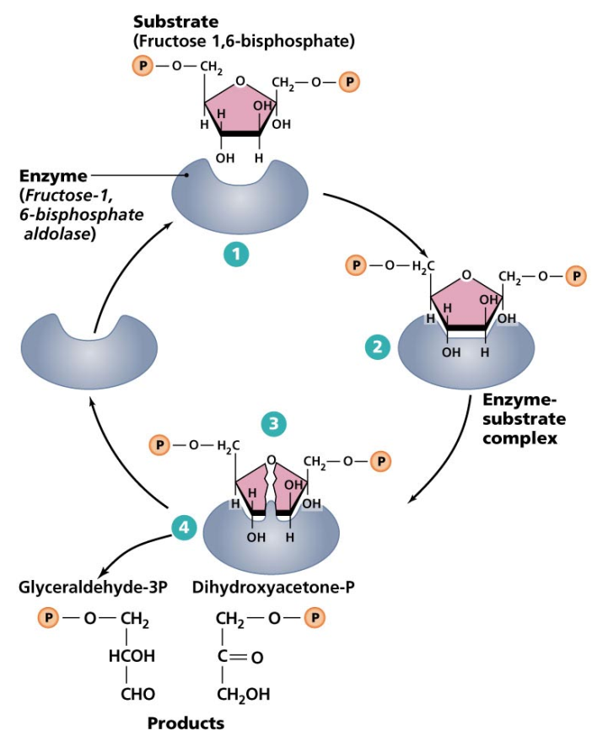

**Enzyme Kinetics**

Enzyme kinetics is the study of rates (velocities) of enzymatic reaction.

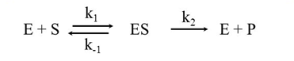

**Michaelis Menten Equation**

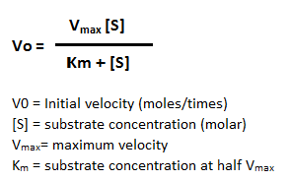 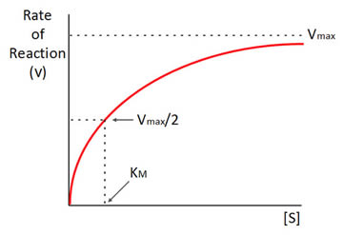

Where,

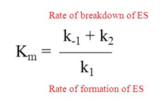

**Types of Enzyme Inhibition**

**Competitive inhibition**

An inhibitor may bind to an enzyme and block binding of the substrate, for example, by attaching to the active site. This is called **competitive inhibition**, because the inhibitor “competes” with the substrate for the enzyme active site. That is, only the inhibitor or the substrate can be bound at a given moment.

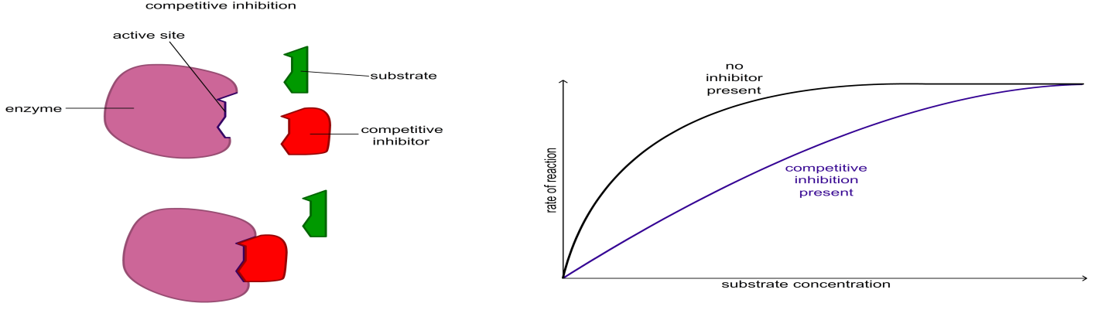

**Non-competitive Inhibition**

In non-competitive reversible inhibition, the inhibitor does not compete with the substrate for the active site. It binds to a different region of the enzyme. This is sometimes called allosteric inhibition (allosteric means ‘another place’ because the inhibitor binds to a different place on the enzyme than the active site).

The result of the binding of the inhibitor is to change the shape of the active site so the substrate no longer fits into it.

Because the substrate and the inhibitor are not competing for the same site on the enzyme, the concentration of the substrate makes no difference to the level of inhibition.

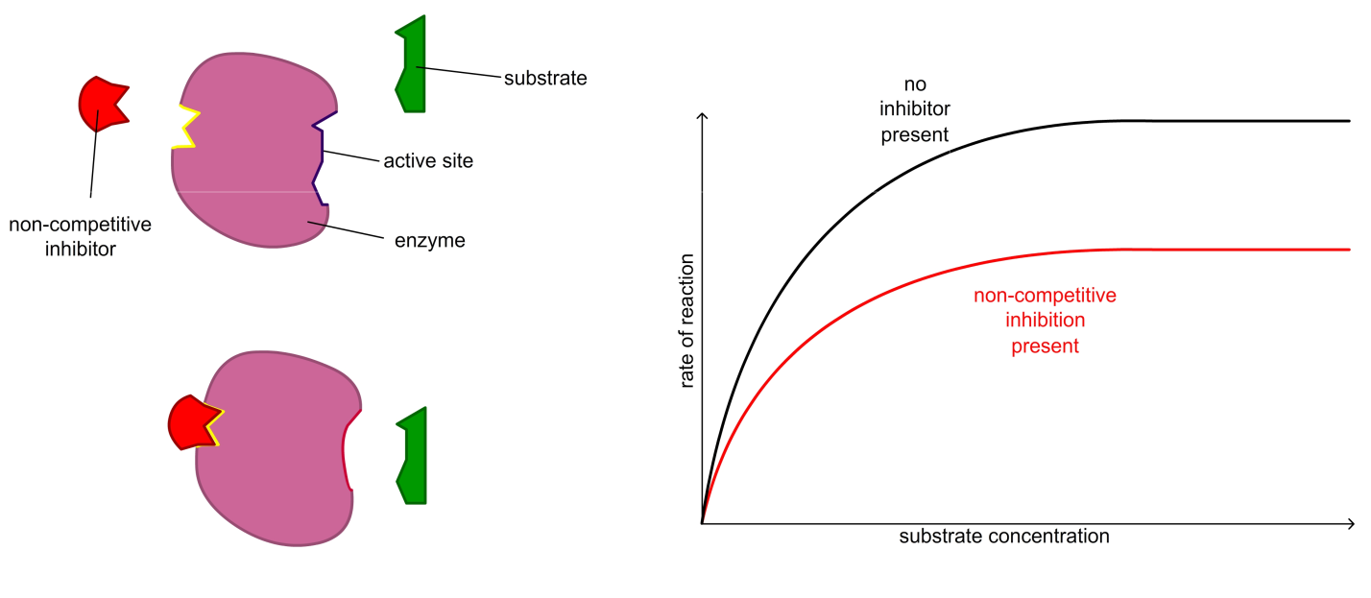

**Uncompetitive Inhibition**

An **uncompetitive inhibitor** is an **inhibitor** that only binds to the enzyme-substrate complex. The formation of its binding site only forms when the enzyme and the substrate have interacted amongst themselves.

