L2: Module 4: Biomolecule
Tertiary Structure
During the third stage, the protein chain folds hundreds of times to form a small ball. Hydrogen bonding is a key component to this stage.
As the proteins fold on themselves, the elements move much closer together which results in very strong bonds.
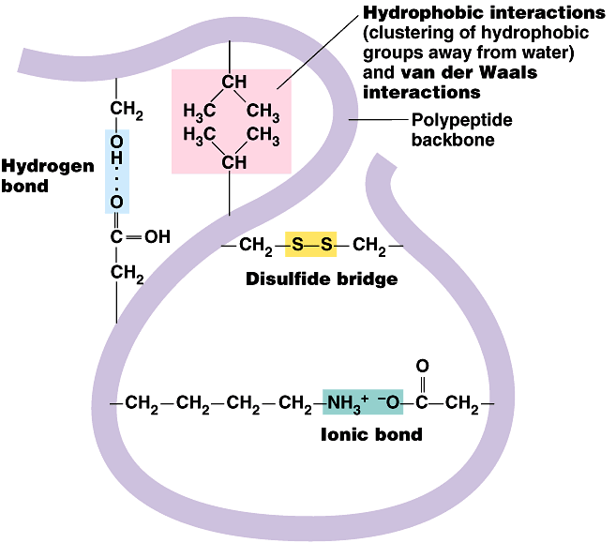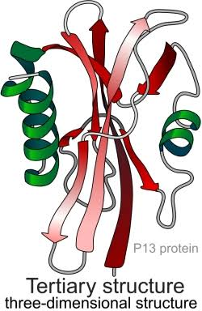
Quaternary structure
Some proteins are made up of multiple polypeptide chains, sometimes with an inorganic component (for example, a haem group in haemoglogin) called a Prosthetic Group. These proteins will only be able to function if all subunits are present.
Quaternary Structure formed when two or more polypeptide chains join together, sometimes with an inorganic component, to form a protein.
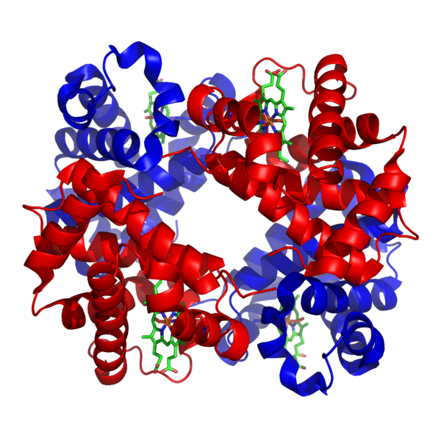
Proteins with a 3D structure fall into two main types:
- Globular - These tend to form ball-like structures where hydrophobic parts are towards the centre and hydrophilic are towards the edges, which makes them water soluble. They usually have metabolic roles, for example: enzymes in all organisms, plasma proteins and antibodies in mammals.
- Fibrous - They proteins form long fibres and mostly consist of repeated sequences of amino acids which are insoluble in water. They usually have structural roles, such as: Collagen in bone and cartilage, Keratin in fingernails and hair.
Denaturation of Protein
Denaturation is a process in which proteins lose the quaternary structure, tertiary structure, and secondary structure which is present in their native state, by application of some external stress or compound such as a strong acid or base, a concentrated inorganic salt, an organic solvent (e.g., alcohol or chloroform), radiation or heat. If proteins in a living cell are denatured, this results in disruption of cell activity and possibly cell death.
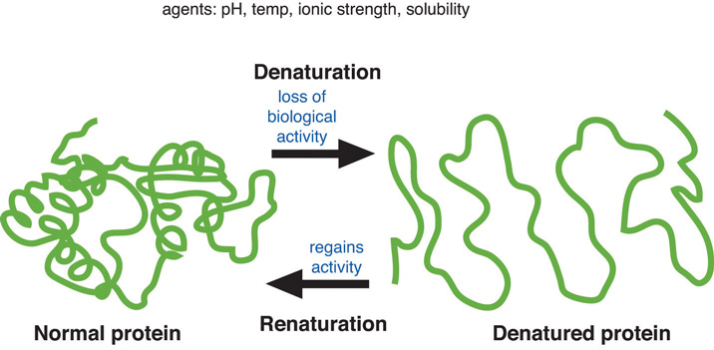
Function of Protein
