L1: Module-5: Enzymes
Enzymology is the study of enzymes, their kinetics, structure, and function, as well as their relation to each other.
A substance that speeds up a chemical reaction—without being a reactant—is called a catalyst. The catalysts for biochemical reactions that happen in living organisms are called enzymes.
Enzymes are usually proteins, though some RNA molecules act as enzymes too.
The molecules upon which enzymes may act are called substrates, and the enzyme converts the substrates into different molecules known as products.
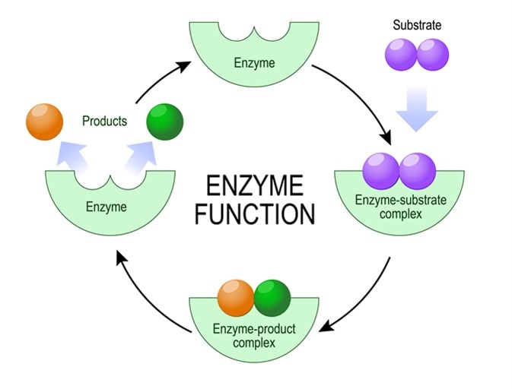
Historical background
French chemist Anselme Payen was the first to discover an enzyme, diastase, in 1833.
A few decades later, when studying the fermentation of sugar to alcohol by yeast, Louis Pasteur concluded that this fermentation was caused by a vital force contained within the yeast cells called "ferments", which were thought to function only within living organisms. He wrote that "alcoholic fermentation is an act correlated with the life and organization of the yeast cells, not with the death or putrefaction of the cells."
In 1877, German physiologist Wilhelm Kühne (1837–1900) first used the term enzyme

Active sites and substrate specificity
To catalyze a reaction, an enzyme will grab on (bind) to one or more reactant molecules. These molecules are the enzyme's substrates.
In some reactions, one substrate is broken down into multiple products. In others, two substrates come together to create one larger molecule
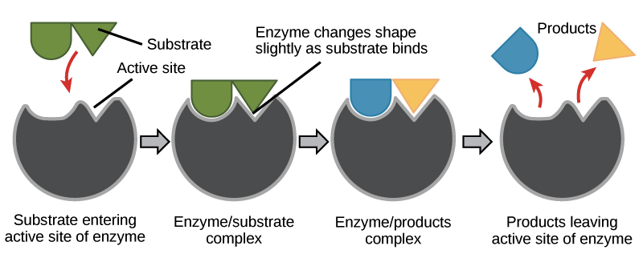
General Features of Enzyme
1. Most biological reactions are catalyze by enzymes
2. Most enzymes are proteins
3. Enzymes are highly specific in reaction and reactants
4. Involvement of co-enzyme and co-factor in some enzyme (prosthetic group, holoenzyme, apoenzyme)
5. Enzymes are sensitive to change in temperature, pH and substrate concentration
6. Enzyme can be inhibited by inhibitors
How does enzyme catalyses reaction?
Enzymes perform the critical task of lowering a reaction's activation energy—that is, the amount of energy that must be put in for the reaction to begin.
Enzymes work by binding to reactant molecules and holding them in such a way that the chemical bond-breaking and bond-forming processes take place more readily.
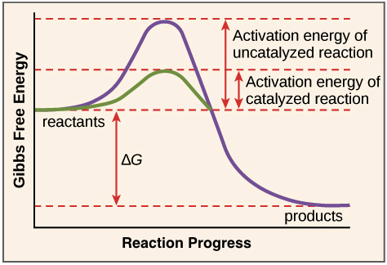
To clarify one important point, enzymes don’t change a reaction’s ∆G value. That is, they don’t change whether a reaction is energy-releasing or energy-absorbing overall. That's because enzymes don’t affect the free energy of the reactants or products.
Instead, enzymes lower the energy of the transition state, an unstable state that products must pass through in order to become reactants. The transition state is at the top of the energy "hill" in the diagram above.
Example- Catalytic action of Glucose phosphorylase
