L1 Module-8: Metabolism
Metabolism is a term that is used to describe all chemical reactions involved in maintaining the living state of the cells and the organism. Metabolism can be conveniently divided into two categories:
- Catabolism - the breakdown of molecules to obtain energy
- Anabolism - the synthesis of all compounds needed by the cells
Metabolism is closely linked to nutrition and the availability of nutrients.
Bioenergetics is a term which describes the biochemical or metabolic pathways by which the cell ultimately obtains energy. Energy formation is one of the vital components of metabolism.
I. Thermodynamics as applied to biological system
The laws of thermodynamic are important unifying principles of biology. These principles govern the chemical processes (metabolism) in all biological organisms.
First Law of Thermodynamics in Biological Systems
The First Law of Thermodynamics, also known as the law of conservation of energy, states that energy can neither be created nor destroyed. It may change from one form to another, but the energy in a closed system remains constant.
Explanation-
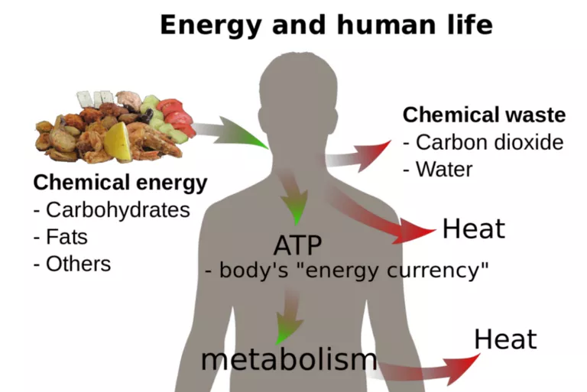
All biological organisms require energy to survive. In a closed system, such as the universe, this energy is not consumed but transformed from one form to another. Cells, for example, perform a number of important processes. These processes require energy.
In photosynthesis, the energy is supplied by the sun. Light energy is absorbed by cells in plant leaves and converted to chemical energy.
The chemical energy is stored in the form of glucose, which is used to form complex carbohydrates necessary to build plant mass.
The energy stored in glucose can also be released through cellular respiration. This process allows plant and animal organisms to access the energy stored in carbohydrates, lipids, and other macromolecules through the production of ATP. This energy is needed to perform cell functions such as DNA replication, mitosis, meiosis, cell movement, endocytosis, exocytosis, and apoptosis
Second Law of Thermodynamics in Biological Systems
The Second Law of Thermodynamics states that when energy is transferred, there will be less energy available at the end of the transfer process than at the beginning.
Due to entropy, which is the measure of disorder in a closed system, all of the available energy will not be useful to the organism. Entropy increases as energy is transferred.
Explanation
As with other biological processes, the transfer of energy is not 100 percent efficient.
In photosynthesis, for example, not all of the light energy is absorbed by the plant. Some energy is reflected and some is lost as heat. The loss of energy to the surrounding environment results in an increase of disorder or entropy.
Unlike plants and other photosynthetic organisms, animals cannot generate energy directly from the sunlight. They must consume plants or other animal organisms for energy.
The higher up an organism is on the food chain, the less available energy it receives from its food sources.
Much of this energy is lost during metabolic processes performed by the producers and primary consumers that are eaten. Therefore, much less energy is available for organisms at higher trophic levels.
The lower the available energy, the less number of organisms can be supported. This is why there are more producers than consumers in an ecosystem.
Living systems require constant energy input to maintain their highly ordered state. Cells, for example, are highly ordered and have low entropy. In the process of maintaining this order, some energy is lost to the surroundings or transformed. So while cells are ordered, the processes performed to maintain that order result in an increase in entropy in the cell's/organism's surroundings. The transfer of energy causes entropy in the universe to increase.
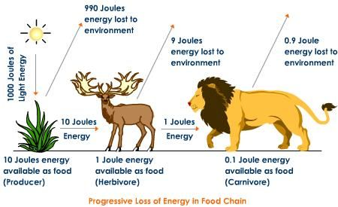
(II) Exothermic and endothermic versus endergonic and exergonic reaction
Endergonic and exergonic are two types of chemical reactions, or processes, in thermochemistry or physical chemistry which describe what happens to any form of energy during the reaction.
While endothermic and exothermic relate only to heat or thermal energy.
Endergonic Reactions
- Endergonic reactions may also be called an unfavorable reaction or nonspontaneous reaction. The reaction requires more energy than you get from it.
- Endergonic reactions absorb energy from their surroundings.
- The chemical bonds that are formed from the reaction are weaker than the chemical bonds that were broken.
- The free energy of the system increases. The change in the standard Gibbs Free Energy (G) of an endergonic reaction is positive (greater than 0).
- The change in entropy (S) decreases.
- Examples of endergonic reactions include endothermic reactions, such as photosynthesis and the melting of ice into liquid water.
- If the temperature of the surroundings decreases, the reaction is endothermic.
Exergonic Reactions
- An exergonic reaction may be called a spontaneous reaction or a favorable reaction.
- Exergonic reactions release energy to the surroundings.
- The chemical bonds formed from the reaction are stronger than those that were broken in the reactants.
- The free energy of the system decreases. The change in the standard Gibbs Free Energy (G) of an exergonic reaction is negative (less than 0).
- The change in entropy (S) increases. Another way to look at it is that the disorder or randomness of the system increases.
- Exergonic reactions occur spontaneously (no outside energy is required to start them).
- Examples of exergonic reactions include exothermic reactions, such as mixing sodium and chlorine to make table salt, combustion, and chemiluminescence (light is the energy that is released).
- If the temperature of the surroundings increases, the reaction is exothermic.
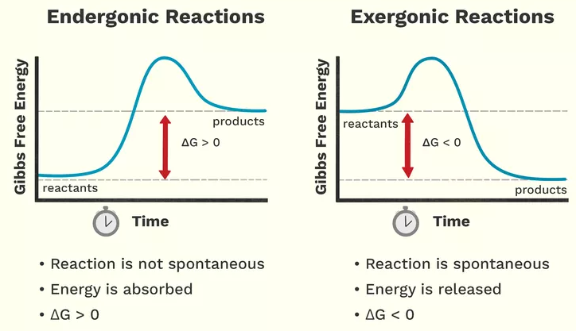

Endothermic Vs Exothermic
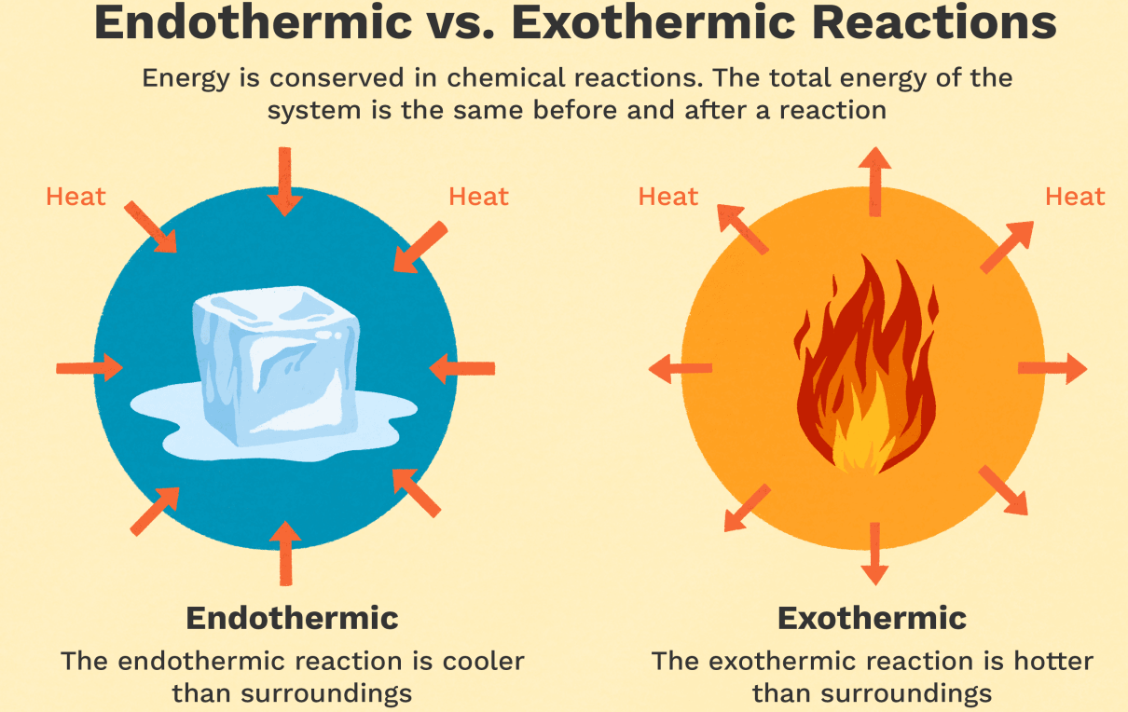
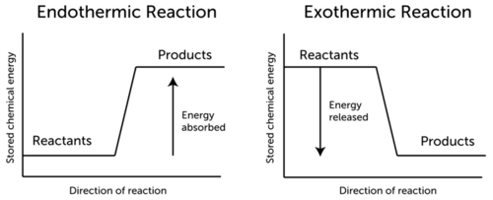
(III) Standard Free Energy and the Equilibrium Constant
Free energy (ΔG)
- The second law of thermodynamics says that the entropy of the universe always increases for a spontaneous process.
- At constant temperature and pressure, the change in Gibbs free energy is defined as
ΔG =ΔH−TΔS
- When ΔG is negative, a process will proceed spontaneously and is referred to as exergonic.
- The spontaneity of a process can depend on the temperature
- As per the 2nd law of thermodynamics, entropy always increases. Life appears different from this trend, spontaneously generating extremely highly ordered structures. Living things decreases their own entropy at the expense of the rest of the universe.
- The free energy of a system (for example the Gibbs energy G = H – TS) is a measure of the entropy change of the entire universe corresponding to changes in the system, and therefore is an indicator of the spontaneous direction of any process of change.
- The processes of life can therefore be considered as the gathering, storage and manipulation of free energy. Most globally, life is driven by the free energy of photons and converts it ultimately into heat.
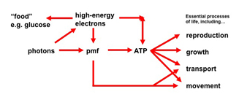
- Free energy can be thought of as the ‘energy currency’ of life: living things gather, store and manipulate sources of free energy.
- Any reaction that requires free energy input (eg. DNA synthesis from nucleic acids, doing mechanical work) must be ‘paid for’ by coupling to a reaction that releases free energy.
- Free energy is handled by chains of coupled chemical reactions or processes, each of which passes free energy from one form to another. Many of the reactions are called electron transport reactions, because they can be described in terms of the transfer of electrons between molecules with different electron affinity.
- Bioenergetics is divided into two: respiration and photosynthesis
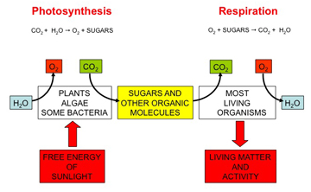
(IV) ATP as energy currency
1. Adenosine 5'-triphosphate, or ATP, is the principal molecule for storing and transferring energy in cells.
2. ATP can be used to store energy for future reactions or be withdrawn to pay for reactions when energy is required by the cell.
3. Animals store the energy obtained from the breakdown of food as ATP. Likewise, plants capture and store the energy they derive from light during photosynthesis in ATP molecules.
4. ATP is able to power cellular processes by transferring a phosphate group to another molecule (a process called phosphorylation). This transfer is carried out by special enzymes that couple the release of energy from ATP to cellular activities that require energy.
Structure of ATP
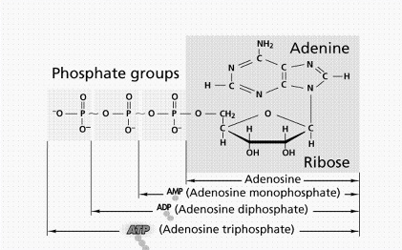
ATP is a nucleotide consisting of an adenine base attached to a ribose sugar, which is attached to three phosphate groups.
These three phosphate groups are linked to one another by two high-energy bonds called phosphoanhydride bonds.
When one phosphate group is removed by breaking a phosphoanhydride bond in a process called hydrolysis, energy is released, and ATP is converted to adenosine diphosphate (ADP).
Likewise, energy is also released when a phosphate is removed from ADP to form adenosine monophosphate (AMP). This free energy can be transferred to other molecules to make unfavorable reactions in a cell favorable.
AMP can then be recycled into ADP or ATP by forming new phosphoanhydride bonds to store energy once again.
In the cell, AMP, ADP, and ATP are constantly interconverted as they participate in biological reactions.

