L1 Module-7: Macromolecule analysis
Protein as transporter
Transport proteins are proteins that transport substances across biological membranes. Transport proteins are found within the membrane itself, where they form a channel, or a carrying mechanism, to allow their substrate to pass from one side to the other.
The substances transported by these proteins can include ions such as sodium and potassium; sugars such as glucose; proteins and messenger molecules; and many more.
Type of transport
Transport proteins generally perform two types of transport:
Facilitated diffusion - a transport protein simply creates an opening for a substance to diffuse down its concentration gradient; and
Active transport- the cell expends energy in order to move a substance against its concentration gradient.
Types of Transport Proteins
1. Channels/Pores
“Channel” or “pore” proteins open holes in the membrane of a cell.
These proteins are characterized by being open to both the intracellular and extracellular space at the same time.
By contrast, carrier proteins are only open to the inside or outside of a cell at any given time.
Channels or pores are typically designed so that only one specific substance can pass through.
Example-
Voltage-gated ion channels in neurons. Voltage-gated ion channels open in response to changes in a membrane’s electrochemical potential.
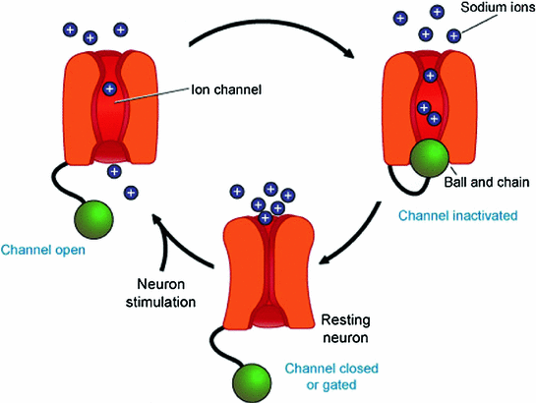
When closed, the voltage-gated channel does not allow ions to pass through the cell membrane. But when open, it allows huge quantities of ions to pass through very quickly, allowing the cell to change its membrane potential rapidly and fire a nerve impulse.
2. Carrier Proteins
Carrier proteins are transport proteins that are only open to one side of the membrane at once.
They transport substances against their concentration gradient.
To accomplish their work, carrier proteins typically use energy to change shape.
Example- The sodium-potassium pump uses the energy of ATP to change its shape from being open to the intracellular solution, to being open to the extracellular solution. This allows it to collect ions inside the cell and release them outside of it, and then vice versa.
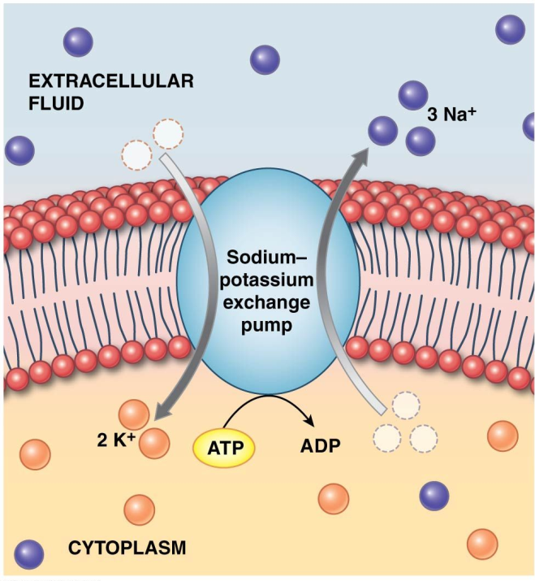
3. Vesicular transport protein is a transmembrane or membrane associated protein. It regulates or facilitates the movement by vesicles of the contents of the cell.
